

[Date]

Submitted to:

Name: Suman Saha

Assistant Professor

Dept. of CSE

at Bangladesh University of Business and Technology.

Submitted by:

Name: Syeda Nowshin Ibnat

ID: 17183103020

Intake: 39

Section: 01

Program:B.Sc. in CSE

Lab Assignment-1

Course Code: CSE 310

Course Title: Operating Systems Lab

Date of Submission: 07.01.2021

Q1 Solution:

Commands:

1. cmp text1.txt text2.txt
2. cmp –i 10:20 text1.txt text2.txt

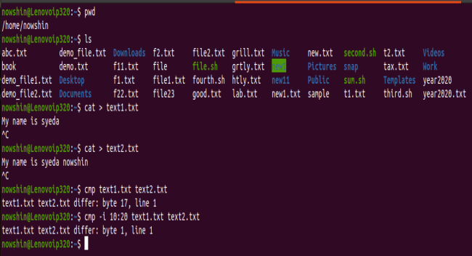

Q2 Solution:

Command:

find –newermt ‘Jul 08,2020’

Q3 Solution:

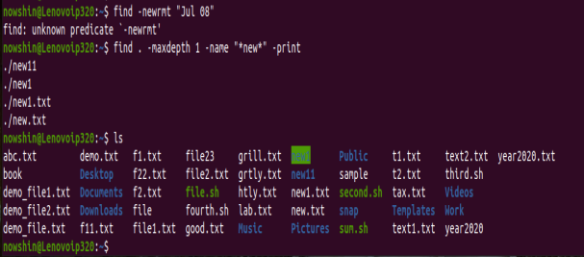

Q4 Solution:

Before:

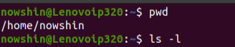



After:





Q5 Solution:

chmod command can be use for this.

I am doing this task for file abc.txt. Removing Execute permission from User/Owner and Adding Execute permission to Group & Others.

Before:



After:



Q6 Solution:

grep command can be use for this.

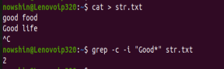

Q7 Solution:

Command:

grep –r amet*

Q8 Solution:

If file having large number of content that won’t fit in output terminal and screen scrolls up very fast, we can use parameters more and less with **cat** command.

Commands:

cat file name | more

cat file name | less

Ex:







Q9 Solution:

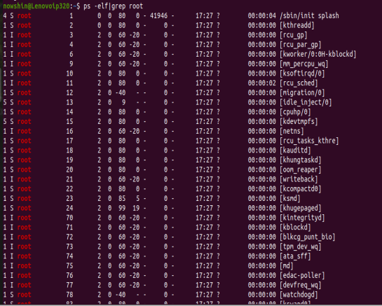

Q10 Solution:

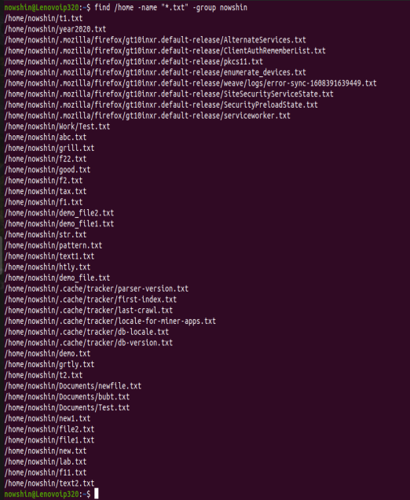

Q11 Solution:

The command name ‘chage’ is an acronym for ‘change age’. This command is used to change the user's password aging/expiry information.

Commands:

sudo chage –E 2022-12-11

chage –W 60 nowshin

Q12 Solution:

